**GNS3**

**Download GNS3 from this link**

<https://www.gns3.com/software/download>

**Download vmware workstation**

<https://filecr.com/windows/vmware-workstation/?id=083025638400>

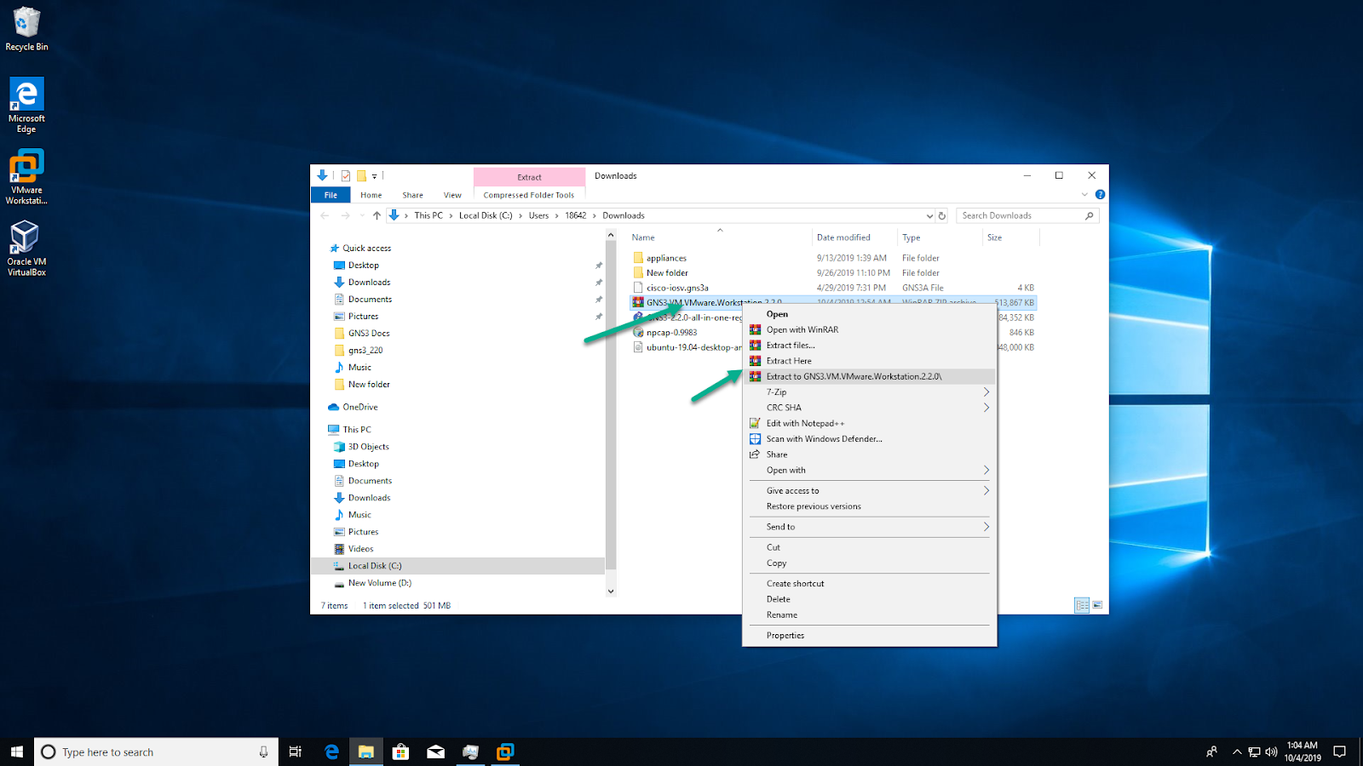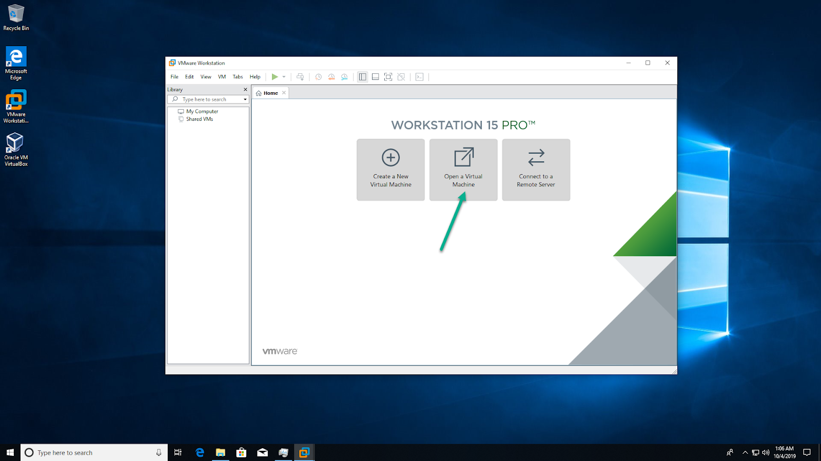

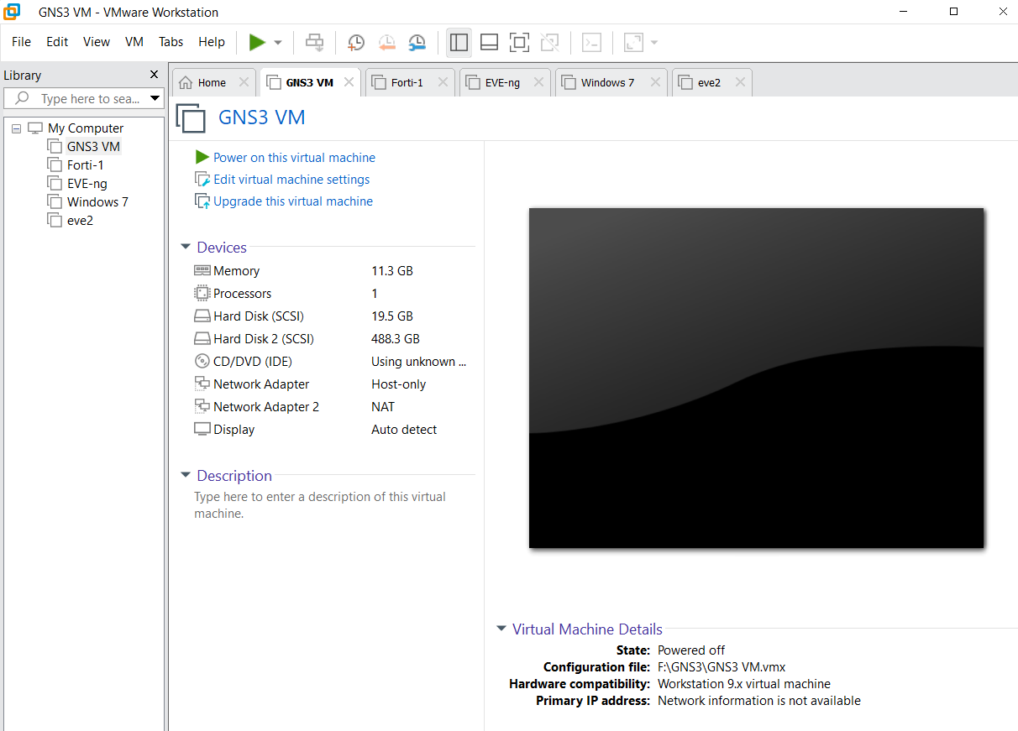

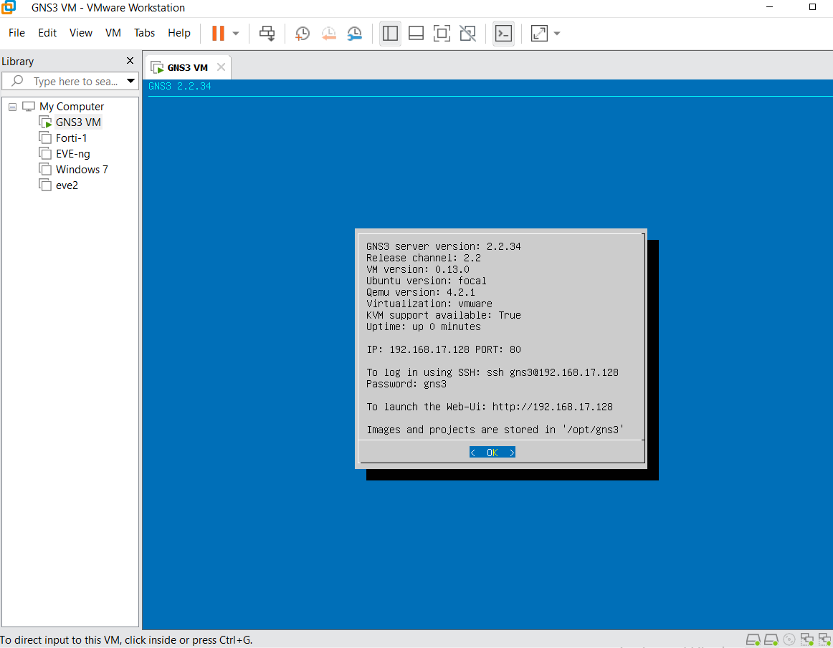

**Local GNS3 VM Setup Wizard**

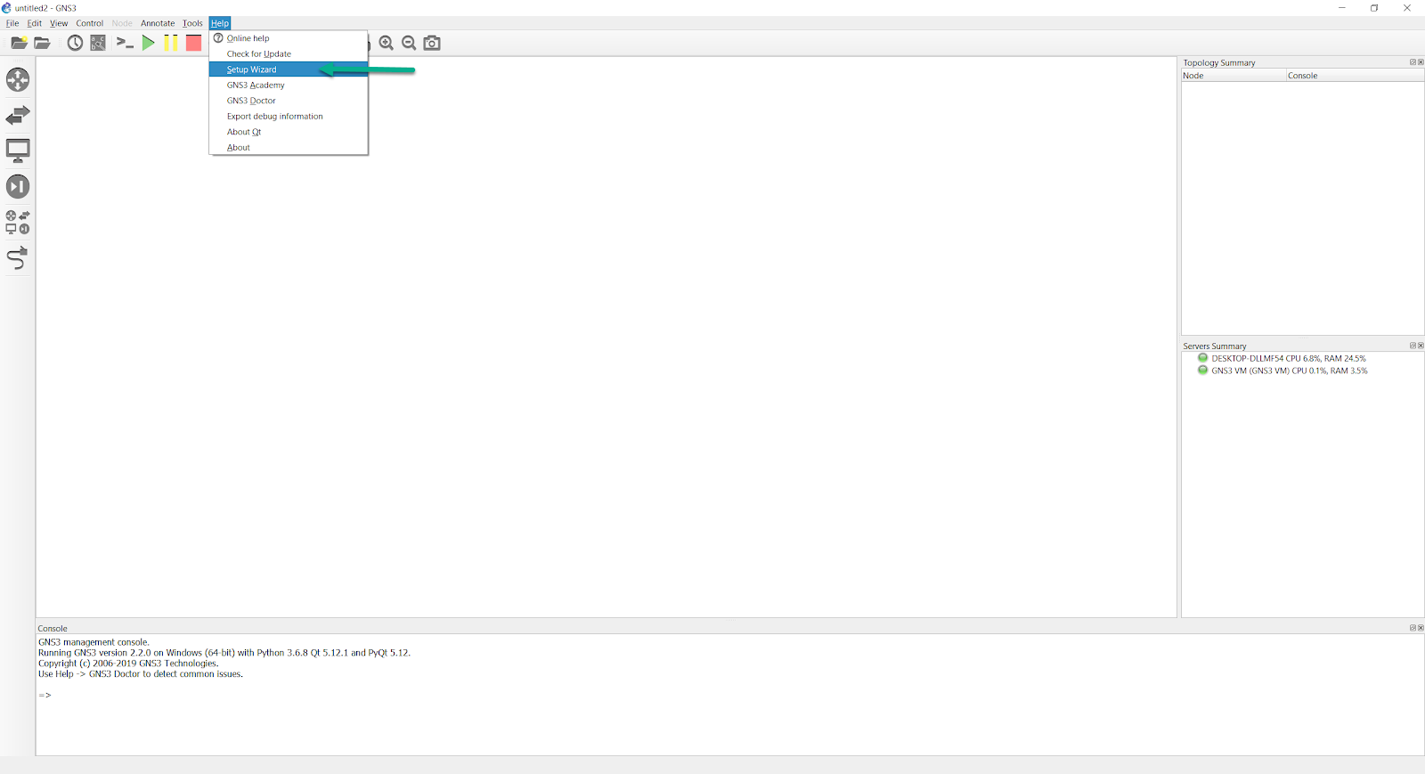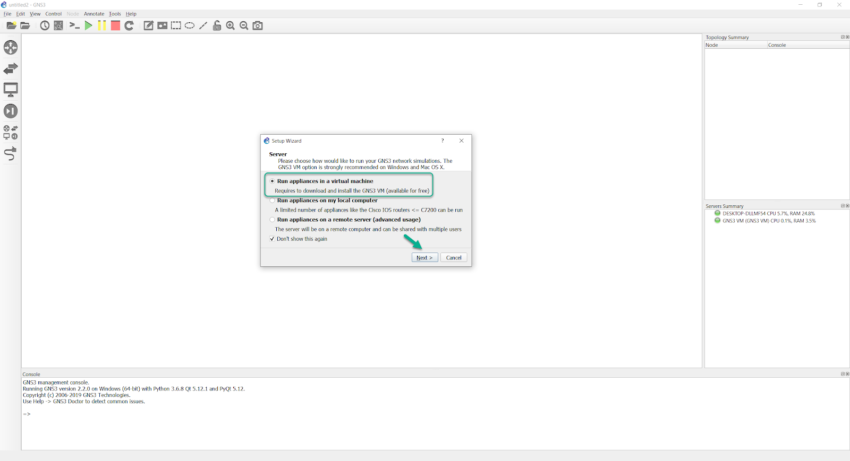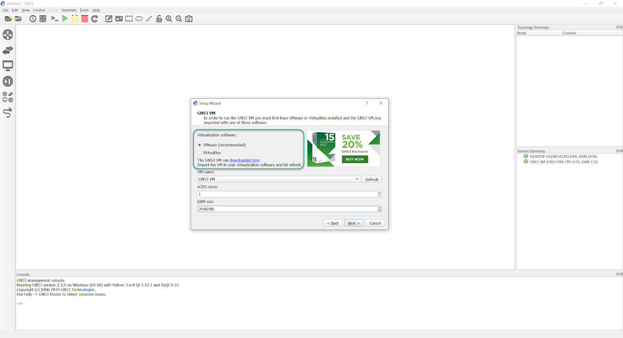

**Then follow below link steps**

<https://docs.gns3.com/docs/getting-started/setup-wizard-gns3-vm/>

**To download any gns3 image you need**

* Install any torrent application on pc e.g, qbittorrent
* Then download below link

<https://drive.google.com/file/d/1LxBaAuteB24Fpg0IYP8fSxjYA4NM9ZY7/view?usp=sharing>

* After download open it using bittorrent app
* Choose what you want to download only (size 370GB)

**Add windows7 to gns3 (Windows _7.qcow2)**

<https://drive.google.com/file/d/17lO6VZgzUXIGqH8fOI8I5loUernQW-S9/view?usp=sharing>

|  |  |
| --- | --- |
| *.bin | edit --> Preferences --> IOS routers --> new --> browse --> open file (c3560-ipbasek9-mz.122-55.SE7.bin) |
| *.image | click **Edit->Preferences->Dynampis>IOS Routers->New** in the GNS3 GUI |
| **\*.qcow** | **Edit> preferences. Go to QEMU > QEMU VMs and hit new. Select the option to run the Qemu VM on the GNS3 VM. Hit next.** |
|  |  |

*.bin files add

Download

**c7200-jk9o3s-mz.124-19.bin**

<https://drive.google.com/file/d/1usQV-cfhriI1_Fhg85q1b7H56xAWGJaP/view?usp=sharing>

**c4500-is-mz.120-7.bin**

<https://drive.google.com/file/d/1spGT7wqieXhX4PzQBEXqLHO6lhthhBW5/view?usp=drive_link>

**c3750-i9-mz.122-18.SE.bin**

<https://drive.google.com/file/d/1JJNwFa_jSvcIkpdg1h6s4Qq8BE9EZAuR/view?usp=drive_link>

**c4000-is-mz.120-7.bin**

<https://drive.google.com/file/d/1vFT9mmb-UN8DH7aci9BY5Giha69WXcmy/view?usp=drive_link>

**c3725-adventerprisek9-mz124-23.bin**

<https://drive.google.com/file/d/1blbUEewxrx1sr6prANgOYuvXbzAAHjg7/view?usp=drive_link>

**c7200-adventerprisek9-mz.152-4.S7.bin**

<https://drive.google.com/file/d/1ATASM6fOq8gSDYTtrIdoC0TttbazxIAY/view?usp=drive_link>

**list of GNS3 images**

<https://drive.google.com/drive/folders/1UJDXE0zYF0LaGoK6EJ8gBewJRCsXpjl1?usp=sharing>

*.qcow

**PA-VM-KVM-10.0.2.qcow2**

<https://drive.google.com/file/d/1oW2Jn7twgaC18rTNHDt4tONmEv3SOmaE/view?usp=drive_link>

**FGT_VM64_KVM-v6-build1066-FORTINET.out.kvm.qcow2**

<https://drive.google.com/file/d/18SnS8OT0ihr4MkFHjzG-Uq18aG6mNqrj/view?usp=drive_link>

**BIGIP-16.1.0-0.0.19.qcow2**

<https://drive.google.com/file/d/1H3QkTh2OB7nmagfmuwbQ4pIG3pMYJKSA/view?usp=sharing>

**junos-media-vsrx-x86-64-vmdisk-20.4R3.8.qcow2**

<https://drive.google.com/file/d/1Q25jPQXH8xjNH1e_RB7axAhCTHR0H0WD/view?usp=sharing>

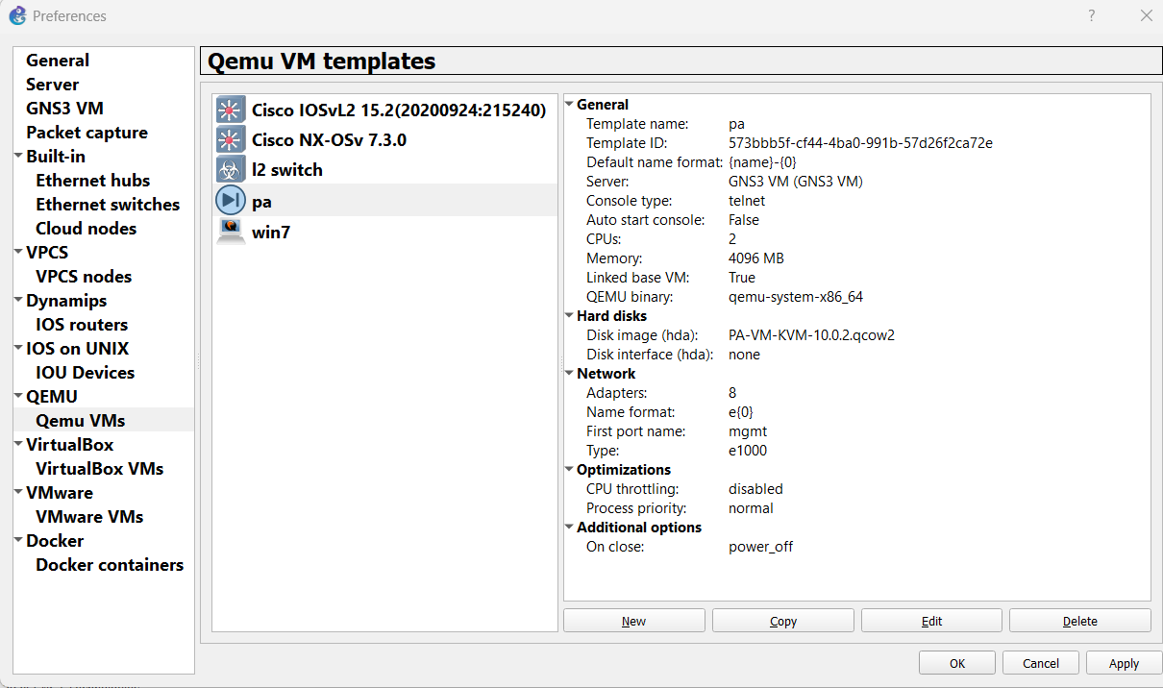

**Cisco IOU,L vIOS L2 L3 Images All (*.image)**

<https://drive.google.com/drive/folders/1DWhz_Edwtd2ujlagxKukqO2BzDlY6HY6?usp=sharing>

**CISCO IOS (Dynamips) (*.image)**

<https://drive.google.com/drive/folders/1jFQADXjqdvQJ2_gAAxQCNCE_Gc6N7D0r?usp=sharing>

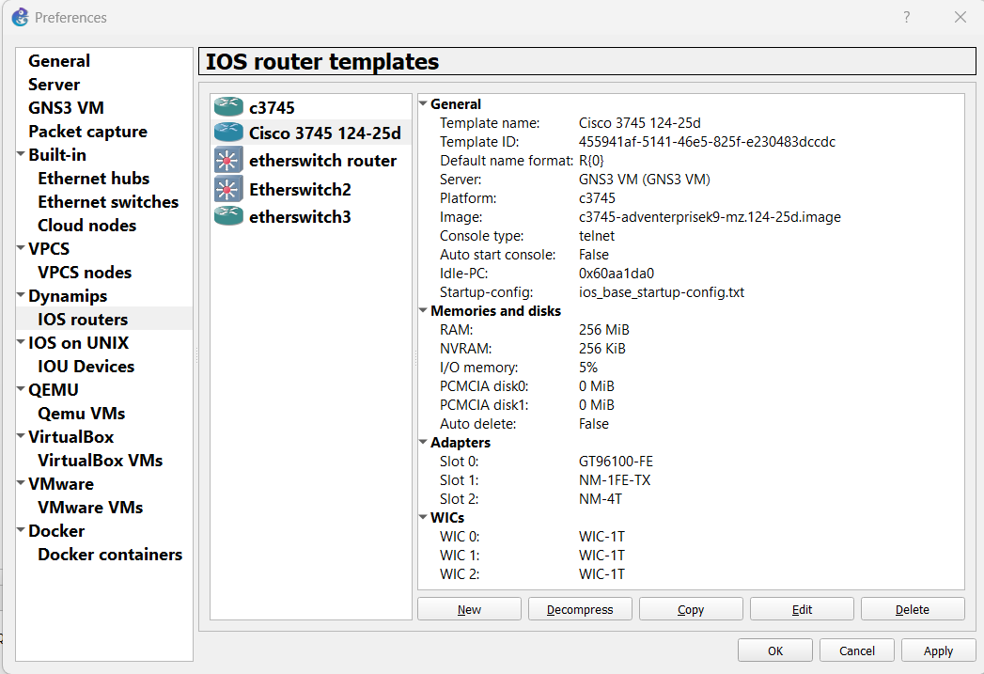

L3 switch

**i86bi-linux-l3-adventerprisek9-15.2.4M1.bin**

<https://drive.google.com/file/d/1YlCPoMQ49JmAx8pqpsLThvfj8k9t_9a8/view?usp=sharing>

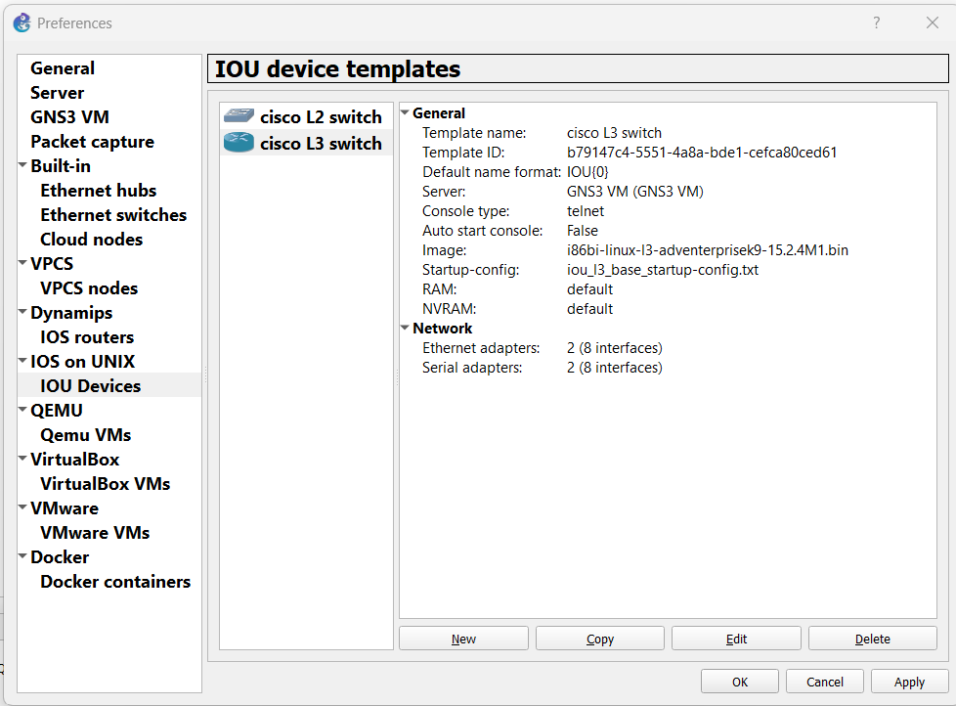

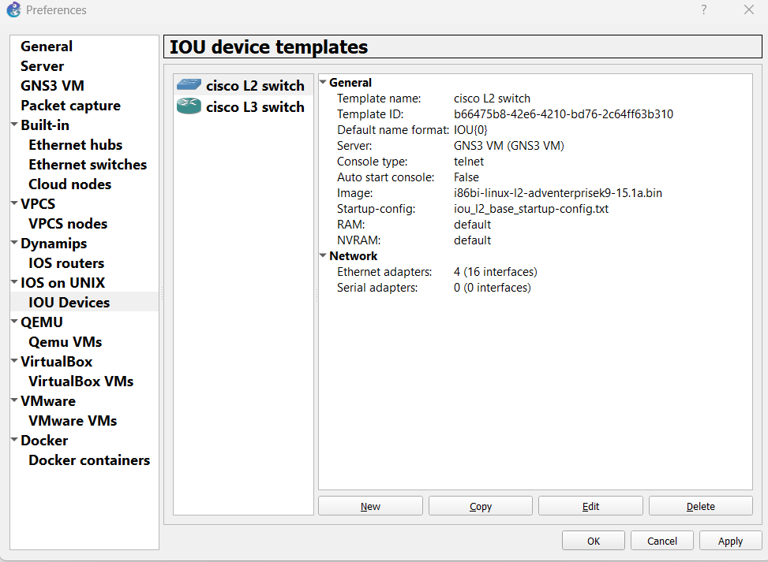

**linux-tinycore-6.4**

<https://drive.google.com/file/d/1KCSvZwAXPHRLZXHRjWsQ571pUK7jllqn/view?usp=sharing>

|  |
| --- |
| **IOU images L2 and L3** |
| i86bi-linux-l2-adventerprise-15.1b.bin  i86bi-linux-l2-adventerprisek9-15.1a.bin  i86bi-linux-l2-ipbasek9-15.1a.bin  i86bi-linux-l2-ipbasek9-15.1b.bin  i86bi-linux-l2-ipbasek9-15.1c.bin  i86bi-linux-l2-ipbasek9-15.1d.bin  i86bi-linux-l2-ipbasek9-15.1e.bin  i86bi-linux-l2-ipbasek9-15.1f.bin  i86bi-linux-l2-ipbasek9-15.1g.bin  i86bi-linux-l2-upk9-12.2.bin  i86bi-linux-l2-upk9-15.0a.bin  i86bi-linux-l2-upk9-15.0b.bin  i86bi-linux-l3-adventerprisek9-12.4.bin  i86bi-linux-l3-adventerprisek9-15.2.2.03T.bin  i86bi-linux-l3-adventerprisek9-15.2.2.15T.bin  i86bi-linux-l3-adventerprisek9-15.2.4M1.bin  i86bi-linux-l3-adventerprisek9-15.3.1.3T.bin  i86bi-linux-l3-adventerprisek9-15.4.1T.bin  i86bi-linux-l3-ipbase-12.4.bin  i86bi-linux-l3-jk9s-15.0.1.bin  i86bi-linux-l3-p-15.0a.bin  i86bi-linux-l3-p-15.0b.bin  i86bi-linux-l3-tpgen-adventerprisek9-12.4.bin  i86bi-linux-l3-tpgen-ipbase-12.4.bin  i86bi-linux-l3-adventerprisek9-15.4.1T.bin |

|  |
| --- |
| routers |
| i86bi-linux-l3-adventerprisek9-15.4.1T.bin |
| i86bi-linux-l3-adventerprisek9-15.4.2T.bin |
| switches |
| i86bi-linux-l2-adventerprisek9-15.1a.bin >>>> L2 |
| i86bi-linux-l3-adventerprisek9-15.2.4M1.bin >>>>L3 |
| i86bi-linux-l2-ipbasek9-15.1e.bin |
| i86bi-linux-l2-adventerprise-15.1b.bin |
| i86bi-linux-l2-adventerprisek9-15.2d.bin |

**Using a c3725 as an “Etherswitch Router”**